Project Yoda: A R.M.A.D.S.D. TALE

# Contents:

## Introduction:

## Technologies:

### Virtual design Mediums :

3D Scanning:

Motion Capture:

Haptic Sculpting:

CAD Programs:

Fusion 360

Blender

Auto Desk123D

Mesh Mixer

Tinker CAD

### Physical Production Mediums:

3D printing

Laser cutting

Resin Casting

## Concept:

Project Premise:

Project MOSCOW:

## Hardware considerations:

Hardware:

Hardware Cost Evaluation:

## Design:

Software Choices:

Design Concepts:

Development iterations:

## Production:

Selected Production Mediums:

Prototype Development cycles:

## Conclusion and Reflection:

## References and Citations:

## Appendices:

# Introduction:

The Aim of this project is to experiment and research and develop a test bed artefact using conceptual design fundamentals such as hinged elements, and mediums of replicated synthetic nature, in this circumstance, “skin-based elements”.

On a simplistic basis the premise of the project occupies an area of animatronics and embedded system design, in order to try and replicate a character-based model with a varying degree of programmable interactivity.

This document will cover the iterative design process from available technologies and how best to utilise them, if at all in some cases, for the relevancy and requirements of the project, to the potential future developments and refinement of the prototypes artifact for further production.

# Technologies:

For the duration of this project, we had access to a multitude of physical production means and virtual design and development tools for utilisation within the greater development process.

Utilising the information of the range of available technology, allowed for a more in depth and informed understanding of what would be capable within the project scope and budget.

## Virtual Design Mediums:

Virtual mediums of design and modelling, tend to prove their use in preconceptual stages, of development, providing fundamental basis for designs, and physical graphical replication of past versions for the purpose of revised development and production.

For the purposes of this project, the use of virtual design mediums proved to be integral in the production of an artifact through CAD Modelling, however the range of available technology allowed for multiple avenues of potential developmental routes.

### 3D Scanning:

3D scanning on a surface level uses optical recognition of known markers to be able to map and recognise an objects external geometry and mapped in a software environment.

This technology provides an extremely intriguing method of inversely modelling an artefact for the purposes for further modification to be done.

For example, 3d scanning a clay sculpture for the purposes of designing a mounting system provides you an extremely accurate model to define the mounting systems parameters and fitment.

Whilst the capabilities of 3d scanning provides the opportunity to “work backwards” in essence, without a physical artifact to begin with, it inherently struggles to prove much use, furthermore the hardware and software requirements, unless custom come at quite the heavy financial cost to maintain and utilise effectively meaning that whilst in this circumstance the access to the technology is present, the volume of the contents and resolution of which the scanner collates is surplus to requirements in this case.

### Motion Capture:

Motion capture in terms of design is potentially an unconventional medium for a project such of this, however, does offer some interesting insights.

The basis of motion capture remains similar to the premises of 3D scanning utilising highly reflective markers and optical image capturing to map geometry in software.

However, in contrast to the 3D scanning process, motion capture (as per its name) focuses on the mapping of the motion of an object, allowing critical evaluation as to the degrees of freedom (DOF) within a required system.

Unfortunately, as per the nature of motion capture, similar to that of 3D scanning the cost and space of operation is highly considerable, furthermore due to specialist software and system integration, the file mediums are not the most transferable between software facilities without a number of intermediary programs for conversion.

### Haptic Sculpting:

Haptic sculpting as a process is more descriptive of haptic feedback in peripheral devices, typically this sort of force feedback system is seen in simulated racing games where the steering wheel peripheral device will provide inverse forces based on software parameters and cases for more responsive and intuitive feedback and design.

Haptic sculpting in these circumstances, was available in the form of a haptic pen which when integrated within the software allowed for intuitive design with an admittedly surreal nature of feeling a software based artefact, physically.

While this technology offered more versatility, the design methods of the haptic pen lent itself more towards voxel based sculpting methods for surface detail, allowing for in cases where the artefact required high amounts of small meticulous detail.

Potentially this could prove to be a useful utensil in the project, however the value of the force feedback, and its related improvement in the ability to virtually design artefacts could be argued one way, or another based on experience with computer aided designing before hand as to how useful the haptic pen would prove in the process.

### CAD Programs:

Computer aided design, typically refers to a range of programs which is intended for some degree of design, for the most part the software is specialised for three dimensional integration, however CAD can also be utilised for designing purposes in two dimensional space for the purpose of CNC machines, laser cutters or similar means of production.

Due to the popularity of CAD programs, multiple companies have their own offerings in terms of platforms and systems, typically the programs either have varying functionalities, intended audiences, or levels of accessibility, to create a point of access for a diverse range of users.

As a result, in the diversity of potential platforms, depending on user experience and their respective intentions with the program for their end product.

#### Fusion 360:

Fusion 360 is arguably one of the most prevalent design, program for general use, focusing on being a versatile 3D and 2D modelling tool, with an impressive extent of rendering capabilities for more artefacts on more of a display focused element.

An element particular of interest within the fusion 360 library of functionality is the generative design capabilities of which though the incorporation of A.I. given general design parameters, the software designs with a degree of autonomy, the method isn’t without failure, however can provide the majority of the concept in terms of design, even with the ability to place priority in design to achieve certain properties of the design, should that be reduced weight of the part, or increasing the strength throughout a structure.

As a result, fusion proves to be an extremely viable platform for the development of relatively structured articles, however for more dynamic and fluid structures, perhaps character creation or high-resolution models, the software tends not to be as ideal for manipulating and modifying models.

#### Blender:

Blender could be considered as something as a mixed bag as it can be used for the purposes of CAD, however it also has an area of integration in animation and game design.

As a result, the purposes of blender tend towards that of less rigid artefacts and trend towards high resolution abstract works, for example sculpt work on dynamic pieces.

Whilst given blenders animation and high resolution capabilities, blender offers a high range of versatility for the creation and display of virtual assets.

#### Auto Desk123D:

#### Auto Desk 123D, is not exactly a typical program which would be discussed in development, mainly due to the fact that the software was discontinued by Autodesk in 2017, due to an “over complicated portfolio”, however there’s a level of discussion to be had as their current portfolio consists of a similar number of offerings.

#### It could be further argued that they had a desire to eliminate their past software due to the programs being free and extremely accessible, for the compromise of creating a universal subscription model.

However. Since corporate business model transitioning is not the aim of this document, we’ll avoid the subject.

123D as a platform provides an extremely accessible and intuitive design approach most commonly for 3D assets, however is capable of 2D designs should it be required.

The main issues presented by the program is due to the age, unless a user has an old installation, like myself, or use less than legitimate means of sourcing the original files, its not easy to gain access, further problems is the program is capable of texturing components, however not for rendering, which for lower end devices attempting CAD to a relatively complex degree is still capable of managing the workload, however loading in complex mesh’s will result in significant performance limitations, therefore for object creation, the software is incredibly useful, this may potentially be due to having 8 years of experience with the program, and many fantastic results, including the majority of components produced for this project, my opinion may be somewhat skewed.

However, for more complex file editing and mesh manipulation alternative programs should ideally be used.

#### Mesh Mixer:

Mesh Mixer similar to 123D is a no longer fully supported program from Autodesk, often considered a partner app to 123D for the purposes of repairing object meshes.

The software offers a decent range of sculpting capabilities, however unlike 123D provides a relatively low performance, high resolution mesh editing facility, therefore proving extremely useful in terms of catering for the functionality which 123D, as a stand alone would struggle to manage internally.

The main issue with mesh mixer as a result of being perceived as an extra tool to 123D, is the fact that the software has relatively minimal functionality as a standalone, whilst the software can be configured to operate in 3d printer parameters and sometimes even with the added capabilities of a slicer, these two programs tend to be quite closely associated for good reason in order to maintain a universal solution for most CAD purposes, thankfully, since this has been discontinued, like 123D access has been somewhat limited, however I have access to the original installation, therefore between the two programs, having a great range of free and intuitive tools for the purposes of the project.

#### Tinker CAD:

Tinker CAD , unlike the other software discussed, is entirely web based, offering arguably the most accessible platform for CAD work, and due to offloading most of the functionality through Tinker CAD’s greater service as a whole, it is capable of being utilised without higher end specifications in device, unfortunately I have found the program somewhat unintuitive and even temperamental based on internet connection at certain times, while as a quick utensil for either viewing or using their library of premade components, for higher level CAD creations, it does not prove to be the most reliable of programs.

## Physical Production Mediums:

Physical Deign mediums, refers to methods of which we can take most of the resultant components of the previously discussed virtual mediums and through various means generate a physical item in various methods and materials, depending on the variation of circumstances, and the requirements of the component.

### 3D printing

3D printing is considered as one method of “additive manufacturing” which contrary to most mediums such as milling and CNC machines, rather than material being removed to generate a structure, the component is actually formed through adhesion and the addition of material to the work area.

This technology has become relatively well commercialised and widely available, it has also taken a variety of differing formats and capabilities as such, however the two main mediums we are concerned with are SLA and FDM, for the purposes of this project.

#### FDM VS SLA:

FDM represent the typical form of molten plastic based substances being manipulated and formed via specialised scripting called g-code, generated in an external program called a slicer, this method of 3D printing, whilst being a perceived majority of current available 3D printing, was not the first method of which the premise of a 3D printer was made.

The first 3D printer was made in 1981 by Dr Hideo Kodama, and took the method of making a SLA 3D printer, a printer with the basis of using a “vat” of material typically resin, placed on a display, which similar to a slicer displays the individual layers of a model and hardens the resin to generate the layers on an upside down print surface, the axis then moves upwards then hardens another layer.

SLA and FDM while fundamentally a similar concept, as a result offer hugely different benefits and consequences as a result of their differences.

Typical issues found with SLA is that due to the resin used in the printers being UV sensitive, they require containment to prevent undesired defect in the printed component, further more the vat capacity tends to be relatively minimal requiring a level of intervention , and unlike FDM, it is not necessarily apparent when there is a lacking of source material.

Further tribulations of the SLA process it the clean-up process required after the production of the part, due to residual resin remaining on the surface of the part, the component requires a Isopropyl alcohol cleaning (or similar substitute), followed by further cleaning, and a curing process, as a result even thought the print time of resin 3d printers on a quality basis tends to be a faster process than FDM, the finishing of an item takes much longer.

However, as a result of the use of curable resin, the resolution of the print tends to provide much higher accuracy and resolution to the designed component, in comparison to FDM, meaning that for extremely high detail structures which require either high precision, or a high measure of surface detail, this method tends to pose the most suitable option.

On the other hand, FDM as a 3d printing method offers a arguably more appropriate rapid prototyping medium, due to the reduction In post print maintenance, and the greater range of usable materials, FDM does arguably prove to be the more suitable method, also related to my personal 5 years of experience with regards FDM 3D printing, optimising and streamlining the FDM production process, proves easier and more reliable for the duration of this projects rapid prototyping method.

Typically, FDM utilises a material known as PLA (poly lactic acid) a very versatile starch based plastic, however due to the significant heating of the plastic during the printing process it has been found to release potentially harmful particulates, which raises moderate concern over the safety of being in close proximity to the printer while in operation, therefore a contained environment is recommended.

Alternatively FDM can use materials such as ABS, an oil based plastic with high strength, but proves to have a high contraction therefore difficult to print, TPU, a flexible material allowing for more creative ways and further use cases of 3D printed parts, however due to elasticity proves difficult due to getting “chewed up” within the feeding gears of the 3D printer, and even materials to the extent of carbon fibre can be printed with due to using a base plastic infused with carbon fibre, however due to the abrasiveness of the infusion can result in damage to the nozzle should the nozzle not be of suitable tempering to endure the material.

Overall, both methods offer great versatility in terms of what can be produced within a rapid time frame for the product development cycle, for the project, however the capabilities and familiarity with not only using, but designing to FDM 3D printer parameters and requirements will most likely prove to be the most prevalently used element within this project.

### Laser cutting

Laser cutting, as a process and in terms of hardware is remarkably similar to that of 3d printing, utilising two instead of three axis’ of movement, to manipulate a laser module.

However, as a result of only utilising two axis for cutting, laser cutters are capable of efficiently cutting and engraving, by varying the intensity of the laser, allows for extremely high precision in the components produced.

For the basis of this project there is not a requirement for this, however depending on the laser cutter, there is a limit to the thickness and capable materials which can be utilised, as typically the majority of materials produce some harmful particulates, not necessarily desirable to be taken in a person’s respiratory system.

### Resin Casting

Resin casting as a method for the project, would be utilised for the re casting of a premade part into a substituted material.

Utilising a silicone cast of components allows for a high precision master solid component to be produced, cast, then re cast In higher quantities and shorter durations as a means of changing the properties of a components initial construction to a substitute structure. This would prove useful in many cases; however, resin casting inherently has some potential issues with the process.

For example moulds made of components can be used a couple of times, however result in either mould degradation or complete destruction, it is possible to prevent this with fibre glass reinforcement, however to maintain accuracy of the mould, the master component would have to be recast if produced in large enough quantities, fortunately due to the prototype nature of this project, whilst a few castings may be done, the requirement to consider the longevity of moulding components does not need heavy evaluation.

# Concept:

The basis of the project maintained two main parameters for an artefact to be constructed, ` a skin based element, and a hinged component.

As a result of extremely loose parameters, the project gave rise to the opportunity to diversify technologies and offer the ability for innovation and creative to take form.

## Project Premise:

Fundamentally, whilst incorporating the initial parameters, the intention was to create a character based animatronic statuette.

The Character of Yoda was chosen for the purposes of Yoda being a “cool” character, as well as having basis in puppetry and animatronic origins in live action media, meaning that source material and reference points to character design is readily available, furthermore, Yoda is “cool”.

Basing the parameter now of character design, the considerations for programmable motorised movements proved appealing to create a level of realism and interactivity with the artefact.

As a result of programmable motor control being a desirable aspect of the artefact, inherently a method of programming the motors must be included to program PWM inputs.

## Project MOSCOW:

The Moscow structure allows a project to outline the initial parameter of what, must be included, Should be included, Could be included, and finally what the project will not include.

### Must Have:

Hinged element incorporated into the design, preferably custom in nature allowing for a level of use or articulation to a component.

“Skin” based element, creating a sense of realism to the project either replicating a skin texture and material, or to the extent of feathers / fur should the thematic sense of the project requires it.

### Should Have:

Servo Motor enabled points of articulation, due to project scope and time frame, this may range from one to three motors based on budgetary restraints.

Micro controller, motor driving integration allowing for programmable actions and movements.

### Could Have:

MP3 Audio Playing capabilities, and respective sound system allowing for pre-loaded speech/ sound effects allowing for increased realism of the project.

### Won’t Have:

Due to not being able to work miracles, the project will remain stationary, excluding the need for traction-based movement, or simulated walking, in order to increase the reliability and integrity of the project.

# Hardware considerations:

Considering the intended expansion into adding program based capabilities to the project, it is essential to consider what electronic hardware will be utilised in the project scope.

### Hardware:

### Due to the smaller scale of the project and autonomy being a core focus, the shift in view focuses on embedded systems and micro controllers.

Given the significance of embedded systems, micro controllers for both hobbyist and professional use are available in diverse abundance.

For the project consideration, our sights will be set on three main options, raspberry pi’s, Arduino, and teensy, microcontrollers.

Raspberry pi’s are highly capable boards, with some of the proposed portfolio managing wi-fi integration, however as a result the controller reaches a price point and level of sophistication not necessarily suitable for the project scope, therefore will not be used in the base design and control of the projects system architecture.

Arduino and Teensy microcontrollers, are arguably similar in a number of ways, both utilising the same base programming environment, the main differences come in the form of performance values, the teensy

microcontrollers maintain a much smaller physical profile in comparison to Arduino processors, however offer magnitudes more processing capabilities, unfortunately as a result, and similar to the issue of price proving excessive for the for the project scope and requirements.

As something of a logical elimination of controllers the Arduino system offers an affordable platform for integration to the system, whilst also providing room for developmental expansion should further features be added in development, or as a test bed artefact for electronic component testing.

### Hardware Cost Evaluation:

The microcontroller proves integral for the majority of the system to be able to function independently, besides controller, a design approach of 3 motors is considered to allow for head point of articulation, and a point of articulation for each arm.

Further potential considerations for the audio system would prove useful and an interesting development to increase the realism and range of system abilities.

|  |  |  |
| --- | --- | --- |
| Component | Quantity | Cost / unit |
| Arduino Uno | 1 | £10-15 |
| Servo Motors | 3 | £3-5 |
| MP3 module | 1 | £5-6 |
| Speaker | 1-2 | £4-5 |

​

​

​

​

​

Whilst this costing analysis for the components is respective to the cost per fully produced prototype, the ability of bulk buying some of these components will result in a lower overall cost per prototype ratio.

# Design:

Beginning the design process requires certain conditions and design parameters to be understood, in order to maintain consistency in the overall design and end product, for example in this circumstance, dimensional volume and relative scaling of the design to stay proportionally in line with the character dimensions, as well as ensuring that the designed components maintain compatibility to the chosen electronic components.

## Software Choices:

For the development course of this project numerous software components were used where appropriate to ensure a level of optimisation when it comes to prototyping assemblies in an appropriate time frame.

|  |  |
| --- | --- |
| Program | Purpose/Role |
| Auto Desk 123D | 123D was responsible for the bulk of asset development for this project, utilising its intuitive tool design and transferability in file types and manipulation, may structures which would have taken significantly longer to be produced, or even in some cases would be impossible to create through differing means, could easily be created and iterated should the development process require it. |
| Mesh Mixer | Mesh mixer was used for the purposes of modifying high resolution complex components of this design which struggled to be handled within 123D.  Being able to normalise and create more manufacturing friendly surfaces allowed for a more reliable and efficient production process due to a reduction In required clean-up work and model refinement after the fact. |
| Cura | Cura is essentially an intermediary program called a slicer which allows typical 3d modelled files to be translated in a means which is suitable for 3D printing, which resulted in being one of the most heavily used attributes of the artefacts production process.  By altering internal parameters of the slicer, many factors relating to the subsequent outcome of the structure, relating from strength, to external resolution for sections which require higher detail. |
| Arduino | The Arduino software, while not used for designing physical components, is used for programming the integrated electronic components of the prototype.  Therefore, plays an essential role in the software design of the artefact. |
| Adobe Illustrator | Adobe illustrator is utilised in this context with the available laser cutting platform to create vector based graphics suitable to be used with laser cutting machines, alternative software can be used, however the available machines for the purposes of easy use, are recommended to utilise the software, |

## Design Concepts:

Conceptual design resulted in the use of the microcontroller component as a structural element in the endo skeleton of the artefact, by allowing the controller not to be encased in typical systems, not only does this provide a scalable constant for the model, it also provides easily accessible I/O interfacing meaning that ease of wiring and expansion is considerably improved.

Considering the mandatory usage of a hinge development, the most appropriate location would be within the arm sub-assembly, due to the scale of the model, choosing an articulated hand assembly would be possible, however given the scale, it would most likely result in fragile elements, therefore placing the hinged element as an elbow based substitute would provide enough deign space to ensure the part would maintain a degree of structural integrity.

With Regards the requirement of a “skin-based” elements, the most appropriate usage within this artefacts contents, would be with respect the organic structures of the project, (head, hands, and feet).

Recasting the organic elements from 3d printed master models will allow for material properties closer to a level of realism in the artefact.

## Development iterations:

The design resulted in an assembly of 7 parts, 6 of which are purely unique parts.

The artefact consists of the following:

* Head x1
* Left Hand x1
* Right Hand x1
* Upper Body x1
* Lower Body x1
* Arms x2

The components listed then can be divided based on functional components, and organic components, as a result both hands and the head structures being classed as organic, and the remainder portions remaining classed as functional structures.

Most organic components were created and normalised within Mesh Mixer, as a result maintain high resolution to the components and required minimal adaptation to connect to the remainder of the functional components.

The components designed within 123D required considerably further understanding and developed integration on the basis of production method parameters.

The upper and lower body sections required a significant over view due to the intention to have these components integrate with the micro controller as a result parameter for motor fitment and screw hole tolerances.

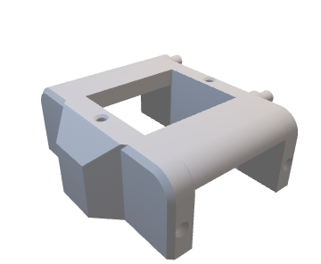

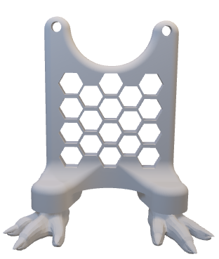

Considerations for the lower section resulted in the property that the hexagonal cut-out section being specified dimensions for the motor cable adaptor to pass through to minimise excess cabling in the system.

Furthermore due to consideration as to the featuring of overhanging structures in the components, these portions are capable of being produced with minimal utilisation of support material in the 3D printing process.

The remaining segment of the bulk of the cad components, is the arms.

The arms maintained a couple of highly important parameters, with regards the hinge segment, however it also had to interface to the motors responsible for the arm motion.

The motor mounting point was designed to maintain a tight fit to the drive gear of the motor, however it was also designed to incorporate a degree of tolerance play to allow the arms once moving to not strain the motor causing potentially catastrophic damage, but would rather use the tolerance to reduce the motion expelled on an obstacle or object saving the greater artefact and electronics from excessive strain.

In conjunction to the mounting section the arm portion went through significant variation based on feature inclusion and the proportional relation of the arms with respect the remaining artefact.

## Version 1/2:

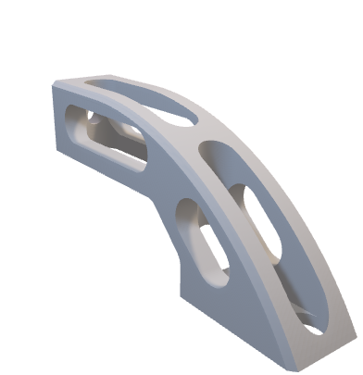Due to system limitations, Version 1 remained problematic, therefore Version 2 is merely the restoration of the first trial version of the prototype component.

The Resultant design had some relatively well rounded geometry for the intention of future layering to the animatronic being able to smoothly flow rather than “catch” on any protruding design elements.

However, due to not having a life size Yoda as reference, the proportions of this concept would have created an impractical and inaccurate silhouette, furthermore this design did not maintain any hinged integration as the development and debate with regards to the hinges positioning was still being considered.

## Version 3:

Version three managed to refine the proportional issues of the previous design, given these new scaling parameters, utilising this structure would have given the prototype more realistic proportional expectations, however this design still does no include a hinged element which would reduce overall fluidity in design and operational motion of the artefact.

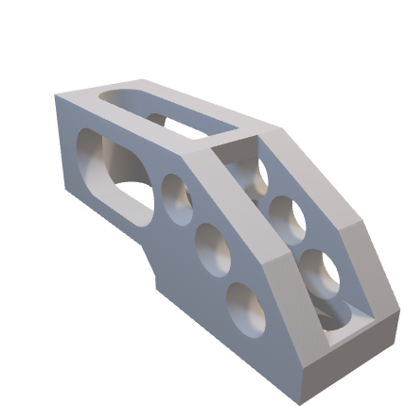

## Version 4:

Version four, was something of a complete redesign, occupying a similar dimensionality of version three, however incorporates the desired hinged element, in a method designed specifically for 3D printing.

The type of hinge incorporated in this design most commonly is referred to as a print in place hinge, this hinge, which by other production means is not possible, utilises the incremental z axis build of the 3D printer to create nested free standing structures, similar to the cross sectional view of Russian nesting dolls.

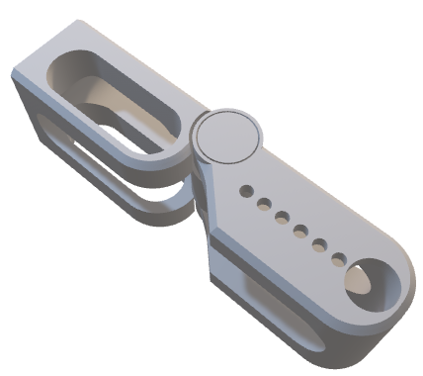By utilising the concepts system of creating interlocked parts (in this case a pivot point, and pivot plates) a singular designed part can incorporate multiple components in a singular production process meaning that assembly time and external hardware is drastically reduced, creating a compound structure which is easy to replace and substitute when required to maintain the hinged components accelerated wear in comparison to more static elements of the artefact.

## Version 5:

Version Five maintains an identical pinion system to that of version four, however shortens the overall length to bring the newly added hinged portion into proportional realism ensuring a relative proportional equilibrium in the artefact.

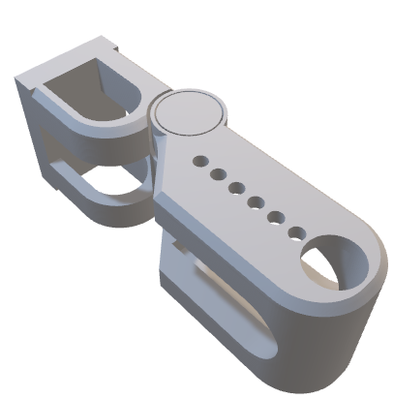

# Production:

Now considering the refinement of the arm design, all required components are suitably developed as far as reasonably possible in a software basis, therefore primary prototype and production is the next developmental process.

## Selected Production Mediums:

Due to the choice of utilising a print in place component for the structure, 3D printing is ultimately the most viable medium to quickly and effective produce the majority of the components of this project.

Further considerations were given to using specifically FDM means of production, as using SLA and resin prints tend to provide more brittle and more difficult to modify parts for the purposes of testing the combination of the components together.

The choice was further made to utilise PLA, as the main material choice due to its “relatively” safe properties, and ease of printing, meaning that the success of a print job is significantly higher and can account for greater atmospheric temperature fluctuations.

For the purposes of reference, the specific 3D printer used was an Ender 3 Pro, which ordinarily provides suitable quality of prints, however in conjunction with years of developing understanding of software based parameters and impactful hardware alterations, I had been able to tune the machine for improved quality, and time of prints, which proved greatly beneficial for the purposes of rapid development.

## Prototype Development cycles:

Since all components were suitably ready for initial tests, and due to being previously acquainted with the Arduino micro controller, most components were available on hand.

The first component to be produced was the head of the artefact.

Since the initial component was produced successfully further components and assembly went ahead to form the resemblance of the torso section.

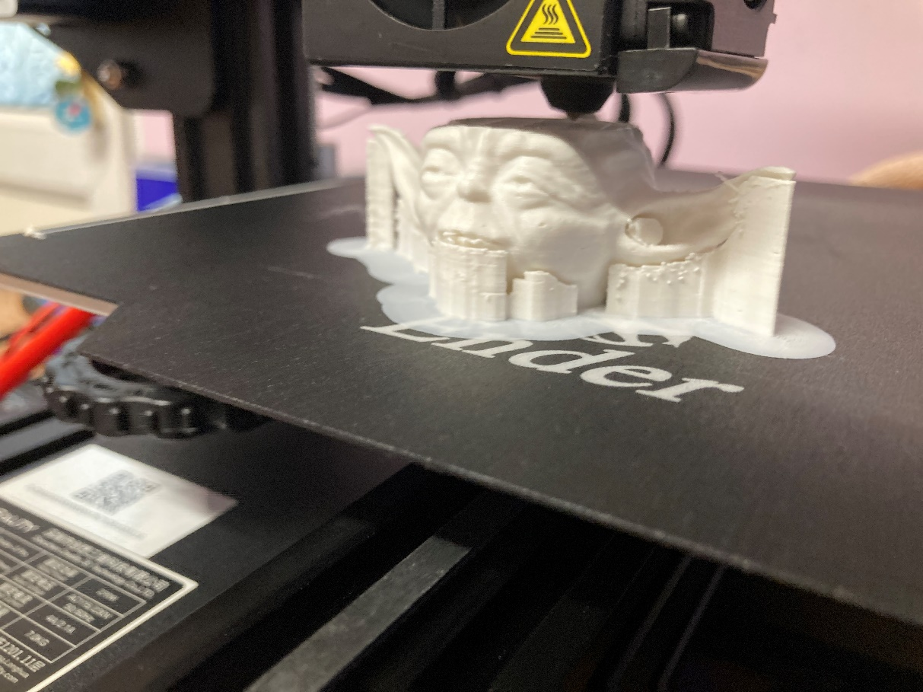

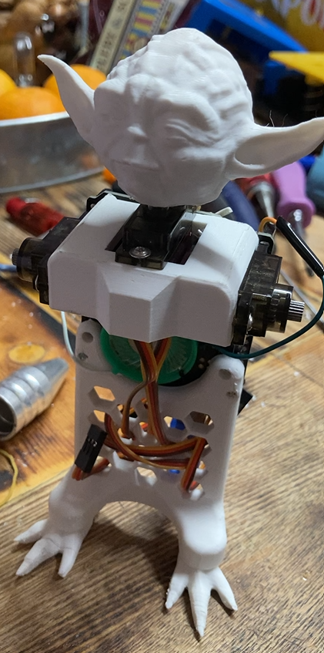

Upon assembly of the upper and lower torso section, due to being early developmental stages, a speaker was added as a substitute “piezo buzzer” which would allow the ability of programming hertz values, to play rudimentary sounds and somewhat recognisable songs.

Also proof of concept for the utilisation of the microcontroller endo skeleton structure proved to be reliable, offering easy I/O access in conjunction of reducing material usage and providing strength across the main body section.

With the addition of the arm components and the hand segments, the functional premise of the artefact Is complete, however evidently is far from being accomplished to the desired level of realism.

To develop the artefact, I opted to attempt sufficient recollection of GCSE textiles to outfit the character with robes of sorts, which would provide a sense of depth rather than just the pure mechanical endo skeletal structure.

The primary robe concept consisted of three main attributes, an under and outer cloak, and a hand woven belt.

Whilst the colouring for the artefact is not near its conclusion, with the outfitting it provides a suitable level of insight as to the intended look of the assembled project.

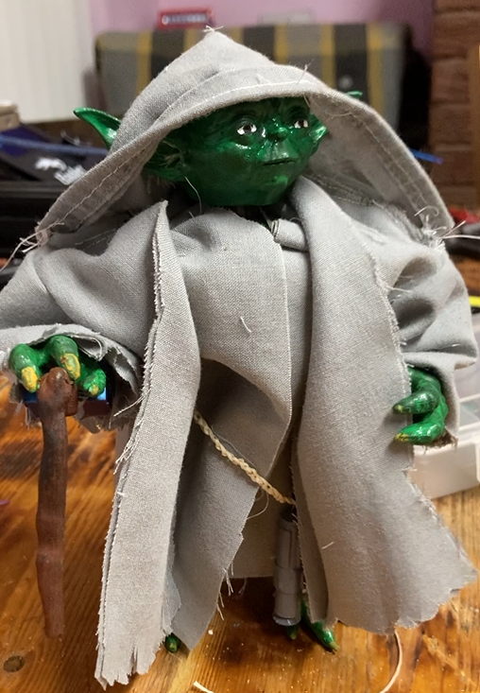

Initial painting resulted in a highly inaccurate colour palette, however as a result, it allowed for two main focuses, further experience of hand painting, and the addition of a walking stick to add to the thematic presence of the character.

Due to the test robe design proving that the internal armature is capable of operating, revisions to the selected material and a few cosmetic alterations were to be made to allow for higher model accuracy.

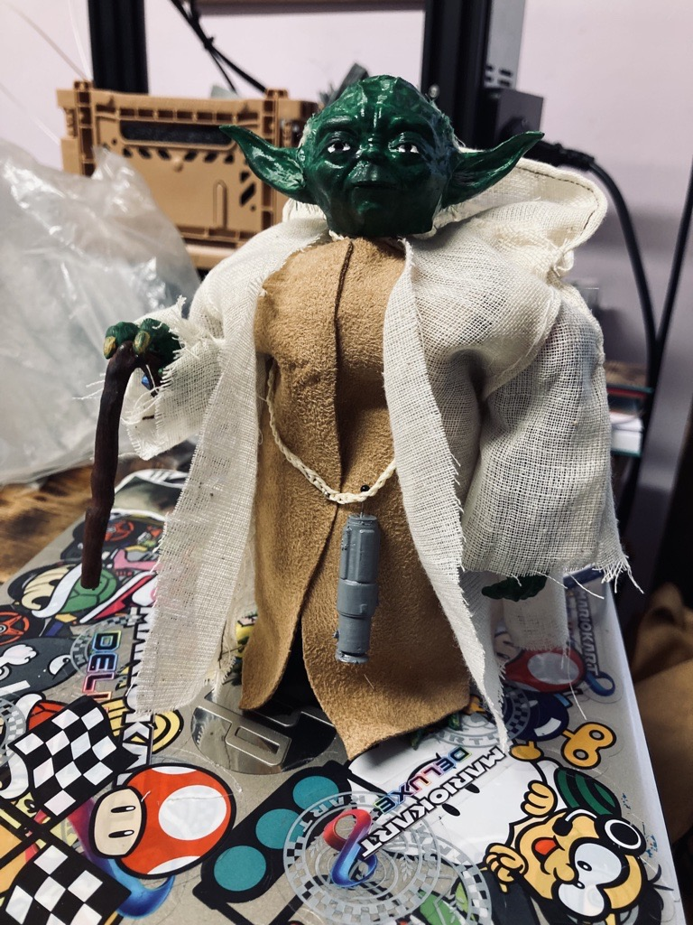

The material selection and second revision of the robe design allowed for improved joint mobility as well as higher source material accuracy.

Further more the addition of the “lightsaber” accessories allowed for further character building and layering to the artefact for source material realism sake.

The main point of contention on the artefact at this stage is the paint choice, as its highly inaccurate and distracts from the colour properties expected from the character, therefore revisions were required.

Utilizing a better colour matched acrylic based paint allowed for a much more improved tone for the character, as a result the initial prototype of the artefact was complete developing the extents of basic audio synthesis, and programmable movements allowing for a simulated animatronic character.

After the first prototype three main developmental factors were to be considered, the stability of the artefact as due to the high density and low footprint size of the model it became prone to falling over, along with bother the reproducibility of the model, and finally improved audio for the purposes of better audio output.

The first issue which was countered was the audio generation, this was accomplished through the use of an external system to the Arduino called a “DF Player Pro” the device around 2 centimetres squared is capable of storing several hours of mp3 audio and providing communications with the Arduin should the desire in future be to connect and interface the two controllers to script lines and actions for further interactivity.

The second issue I faced was replicating the model, therefore two further prototypes were developed.

each of the three versions utilised the premise of if slightly differing hardware would reduce cost as well as improve the versatility of the designs compatibility with differing parameters, therefore both utilise a slightly modified Arduino board for improved ease of connectivity to the motors, and one of the two utilises a nylon based motor rather than the higher durability (and cost) metal geared motors, as a result no subsequent loss in power or ability to move was experienced, and due to less specialised gearing, the substitution lowers the cost of the project per unit going forwards.

Finally the issue of the stability of the system was resolved via an acrylic base which is bolted to the foot portion of the artefact and creates both a display platform and a more reliable surface for which the platform can be programmed and secured via.

## Conclusion and Reflection:

Overall as a project, the experience of being able to develop and create an artefact from the fundamental ground up has proven extremely insightful, the diverse range of available technologies, has meant even though not all the methods were utilised, and the choice to expand into differing technologies and software’s highlighted how in the modelling process, conceptualisation requires a level of iterative development for the success of a projects overview.

Whilst during this project, my personal preferences of software and methods became increasingly prevalent, which even considering past experience, potentially being forced to diversify in approach to technology and methods may create for more innovation in the outcomes and in terms of the artefact, utilising the functionality of the generative design utilities in fusion 360 could have optimised the conceptual design to improve its overall standards.

In reflection the overall artefact remains successful of what it intended to do, and created a blend of design and embedded systems to what is most accurately represented as “desktop animatronics” whilst the reduction in degrees of freedom (DOF) on such a scale may not have the level of complexity of which show worthy production animatronic chassis’ possess, it allows for an accessible platform for expansion and development utilising the character design basis for a more engaging artefact.

## References and Citations:

Me, Myself, and I. (Jan 2023) “how to cry yourself to sleep” .

## Appendices:

Build plate sub-assemblies of all required parts, Available At: <https://github.com/willlaws35/Project-Yoda/tree/main/Yoda%20Parts/Yoda%20Required%20Parts>

Assembly guide and instructions, Available At:

<https://github.com/willlaws35/Project-Yoda/blob/main/Yoda%20Doc/Yoda%20Assembly%20Instructions.docx>